[Skip to content](https://dodgingtherain.wordpress.com/2021/02/14/stephanie-v-sears-re-placement/" \l "content)

**[DODGING THE RAIN](https://dodgingtherain.wordpress.com/)**

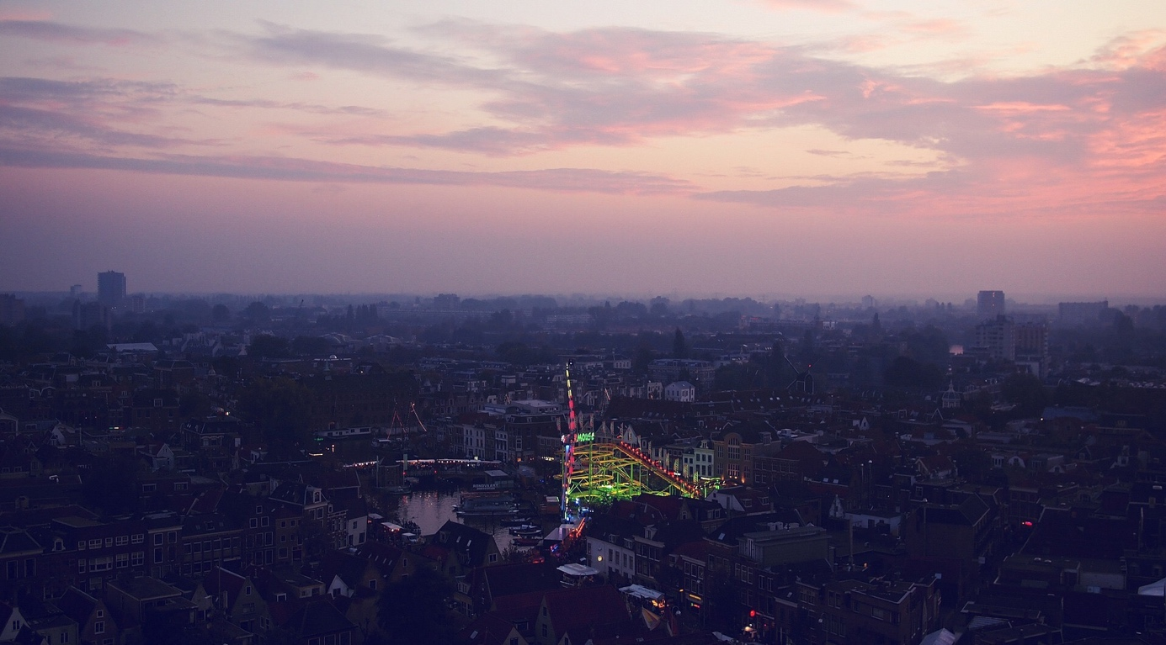

February 14, 2021

**Stephanie V Sears, Re-placement**

**Re-placement**

The gold, the fog, the frost of you  
cloaked me in bliss  
even as the fans spun.

Our gaze was enough  
to forget the dearth of time  
lying about monotonously.

Locked between our eyes  
leopards and tigers thundered  
through recondite jungles.

Down steeper slopes  
their snowy brethren crept  
among the boulders,  
radiant with Himalayan sun.

In its buttered glow  
suddenly I placed you  
in bright knit and mittens

gliding past the mills and ice banks  
in dazzling velocity  
even as you stared so tall  
in the earth hues of travel.

An old century tugged at my blood:  
in a wholesome Lieden attic,  
on a moonlit night crackling stiff  
with icicles and bold bare trees,

we crouched,  
children under the rafters.  
Your boyhood smell of glue and wool clung to me  
as the canal’s hard gleam conjured enchantments.

**Stephanie V Sears** is a French and American ethnologist (Doctorate EHESS, Paris 1993), freelance journalist, essayist, and poet whose poetry recently appeared in *The Deronda Review, The Comstock Review, The Mystic Blue Review, The Big Windows Review, Indefinite Space, The Plum Tree Tavern, Literary Yard, Clementine Unbound, Anti Heroine Chic, DASH,* and *The Dawn Treader.* Her collection *The Strange Travels of Svinhilde Wilson* was published by Adelaide Books in 2020.

**Share this:**

* [Click to share on Twitter (Opens in new window)](https://dodgingtherain.wordpress.com/2021/02/14/stephanie-v-sears-re-placement/?share=twitter&nb=1" \o "Click to share on Twitter" \t "_blank)
* [Click to share on Facebook (Opens in new window)](https://dodgingtherain.wordpress.com/2021/02/14/stephanie-v-sears-re-placement/?share=facebook&nb=1" \o "Click to share on Facebook" \t "_blank)
* [More](https://dodgingtherain.wordpress.com/2021/02/14/stephanie-v-sears-re-placement/)

***Related***

[David Lohrey, Adoration of the Morons](https://dodgingtherain.wordpress.com/2017/09/09/david-lohrey-adoration-of-the-morons/" \o "David Lohrey, Adoration of the Morons)September 9, 2017In "Photography"

[Affairs, adultery, and no end of dark comedy: An Interview with Cheat Sheets Author Edward O’Dwyer](https://dodgingtherain.wordpress.com/2018/09/10/affairs-adultery-and-no-end-of-dark-comedy-an-interview-with-cheat-sheets-author-edward-odwyer/" \o "Affairs, adultery, and no end of dark comedy: An Interview with Cheat Sheets Author Edward O’Dwyer)September 10, 2018In "Fiction"

[Elisabeth Kelly, This Ice Sea](https://dodgingtherain.wordpress.com/2021/01/04/elisabeth-kelly-this-ice-sea/" \o "Elisabeth Kelly, This Ice Sea)January 4, 2021In "Poetry"

Posted in [Poetry](https://dodgingtherain.wordpress.com/category/poetry/)[Leave a comment](https://dodgingtherain.wordpress.com/2021/02/14/stephanie-v-sears-re-placement/" \l "respond)

**Leave a Reply**

Top of Form

Bottom of Form

**Post navigation**

[← Annie Deppe, The Little Rehearsals](https://dodgingtherain.wordpress.com/2021/02/11/7991/)

[jck hnry, walking to work →](https://dodgingtherain.wordpress.com/2021/02/18/jck-hnry-walking-to-work/)

Top of Form

Bottom of Form

Top of Form

Privacy & Cookies: This site uses cookies. By continuing to use this website, you agree to their use.   
To find out more, including how to control cookies, see here: [Cookie Policy](https://automattic.com/cookies)

Bottom of Form

:)